Introduction

Who this book is for:
This book is intended as an introduction for farmers and Cannabis cultivators to the world of fungi, fungal biology, and Cannabis-fungal interactions. Cannabis interacts with fungi in myriad ways throughout its lifecycle and after harvest. Fungal partners provide important benefits to Cannabis plants that improve their growth, survival, and productivity. Unfortunately, the time most growers first come to recognize that fungi are living along with their Cannabis crop is when a pathogenic fungi causes a problem. A comprehensive understanding of Cannabis-fungi interactions will help growers encourage the growth of fungi that benefit their crop and are safe, while excluding and limiting the damage from those that are detrimental to their host plant or the humans who later ingest it.

This book:

This book is divided into 4 sections. Section 1 Is primarily focused on fungal biology and how fungi grow and reproduce. Then in section 2 we describe the mutualistic relationship between Cannabis and fungi, including mycorrhizae, soil fungi and fungal endophytes. Section 3 shifts focus and details many of the fungal pathogens that infect Cannabis plants. We end in section 4 by describing different methods for defending plants against fungal pathogens via breeding, strain selection, foliar treatments and more.

Mycobiome

The entire community of fungi that live inside the plant endophytically, on the surface of plant tissues or epiphytes and pathogenic fungi that cause disease to the plant is called the mycobiome. The phytobiome (or microbiome of the plant) would include these fungi as well as bacteria, viruses and archaea organisms in and on the plant.

This community of microorganisms, especially fungi, is understudied in the Cannabis industry but has been well researched in other crops. Studies have shown that the mycobiome can increase plant resistance to abiotic and biotic stresses, can influence plant secondary metabolite production and may also produce novel fungal metabolites that can alter plant growth (Gwinn et al 2023).

The mycobiome is likely to change over the course of the plant's life and is directly influenced by environmental conditions, such as temperature and humidity, fungicidal applications, and plant genetics (Punja et al 23). Wei et al. reported that the microbiome of the plant is most abundant and diverse in the rhizosphere and decreases in diversity and concentration as you move up the plant into the flower tissue (Wei et al. 2021).

The plants’ fungal community can be acquired vertically from parent to offspring or horizontally from the environment while the plant is growing. Some of these organisms are systemic and can travel from one plant organ to another, typically utilizing the plant's vascular system. Others are restricted to specific parts of the plant and do now move through plant tissue, also known as having compartment niches.

Chapter 1

Intro to Mycology

Chapter 1 gives an introduction to mycology, the study of fungi, which is a constantly evolving field due to how much we still don’t know about fungi and their interactions with other organisms. The chapter explains that fungi are eukaryotic organisms that lack specialized vascular systems, like those in plants or animals. Instead, fungi transport nutrients through a network of hyphal tubes. While all mushrooms are fungi, not all fungi produce mushrooms, and many are microscopic or hidden until they’re ready to reproduce.
Fungi are everywhere, especially in agriculture, where they play vital roles in nutrient cycling and disease suppression. Some fungi form mycorrhizal relationships with plant roots, while others live inside plant tissue as endophytic fungi.
The chapter then shifts to the concept of "the mycology of Cannabis." Cannabis plants always grow alongside fungi and other microbes, so understanding mycology is key to understanding Cannabis. The relationships between fungi and Cannabis can be complex, with interactions that change over time and can vary depending on the environment. Ultimately, these interactions are not just "good" or "bad" but exist on a spectrum, and researchers are still working to fully understand how fungi and plants are interconnected.
To sum it up:
- Mycology is the study of fungi.
- All mushrooms are fungi, but not all fungi produce mushrooms.
- Every plant, including Cannabis, interacts with fungi in various ways.

Chapter 2
Fungal characteristics
Some physical and physiological characteristics of fungi can be useful in identifying fungi to various levels of hierarchical classification. Farmers with an understanding of fungal characteristics are also at an advantage in manipulating them to the benefit of their crop. In this chapter we will be discussing different anatomical features that researchers and growers can use to help identify the particular fungus with which they are working. We will be describing some of the key features that make a fungus a fungus, and not, for instance, a plant. The goal of this chapter is to develop educate readers of fungal traits.
Historically fungi have been grouped closely with plants. To this day, within academia, fungi are generally reserved for the purview of the botanists. Universities with a “Department of Mycology” are exceedingly rare. When a university department or college does include “mycology” in its title, it is almost always paired with the “botany” or “plant pathology” department. Though in hindsight there is an unintentional logic behind this, as these two kingdoms are intimately linked in practice through symbioses, the original grouping of fungi and plants together was an academic mistake.
Fungi superficially grow similarly to plants, with macroscopic forms appearing as sessile organisms with cell walls similar to plants and dependent on dispersal of reproductive structures for survival. Botanists, beginning with Pier Antonio Micheli, who published Nova plantarum genera in 1729, were the first western scientists to pioneer the study of fungi. Pier Antonio Micheli was the first person to show fungi reproduce via spores. Before his experiments showing that spores transferred to a new substrate gave rise to the same species of fungi from which they came, the dominant view had been that fungi spontaneously generate.
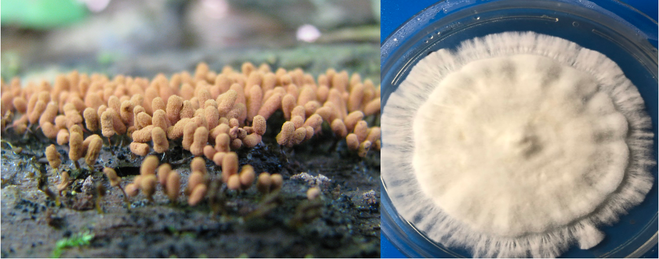
Fig. 2.1 Slime mold (left) vs a true fungus, Psilocybe spp. (right).
Throughout most of history fungi were considered lower plants. Ironically, this tradition of grouping unrelated organisms within an unrelated field continues; the Amoebozoid ‘slime molds’ (Myxostelida, Dictyostelida, Labyrinthulida, and Plasmodiophorida) and the Chromistan ‘fungi’ (Oomycota, Fig. 2.1) are not true fungi. Nonetheless, the similarity of physical appearance, growth characteristics, and economic impacts of these organisms reinforce their retention as a related field to mycology (and likewise mycology to botany).

Table 2.1. Hierarchical classification of 3 domains of life.
Domain | Kingdom | Members
Bacteria | Bacteria | Actinobacteria (Actinomycetota), Proteobacteria (Pseudomonadota), Cyanobacteria (Cyanophyta), Spirochaete (Spirochaetota), ect.
Archaea | Archaea | Extremophiles, methanogens
Eukaryota | Excavata | Various flagellate protozoa
 | Amoebozoa | Most lobose amoeboids and slime molds
 | Opisthokonta | Animals, fungi, choanoflagellates
 | Rhizaria | Radiolaria, and various other amoeboid protozoa
 | Chromalveolata | Stramenopiles (Brown Algae, Diatoms etc.), Haptophyta, Cryptophyta (or cryptomonads), and Alveolata
 | Archaeplastida | Land plants, green algae, red algae, and glaucophytes

Plants and Fungi
The relatedness of fungi and plants has stumped scientists for generations. In the past, scientists were only able to observe morphological characteristics in these organisms and did their best to group them based on these features. Chemical taxonomy helped prove that fungi were physiologically distinct from plants in numerous ways (Figure 8). The aid of molecular genetic sequencing techniques has recently helped further unravel the many mysteries about the relatedness of fungi. Organisms once believed to be fungi have been reclassified as protozoa (including oomycetes and the mycetozoan slime molds,); organisms believed to be protozoa (such as Chytrids, Microsporidia, and Pneumocystis jirovecii) were shown to be fungi. Protozoa itself is a catch-all group of single celled organisms that is non-monophyletic, meaning the grouping contains organisms descending from separate ancestral lines. Therefore it serves only as a classification rather than a systematic grouping representing phylogeny.
As stated before, plants and fungi share a number of similar characteristics but there are also some key differences between the two. To begin, both organisms are eukaryotic with membrane bound organelles, including a nucleus that houses the genetic material, deoxyribonucleic acid (DNA). However, fungi have relatively small nuclei with little repetitive DNA. Fungi can have one to many nuclei per ‘cell.’ Often these are genetically distinct nuclei when plasmogamy (the fusion of independent mycelial bodies) has occurred in the individual's history. Previously, separate individual mycelia may merge together in this way if they have appropriately-matched vegetative or mating compatibility types. Fungi usually have haploid
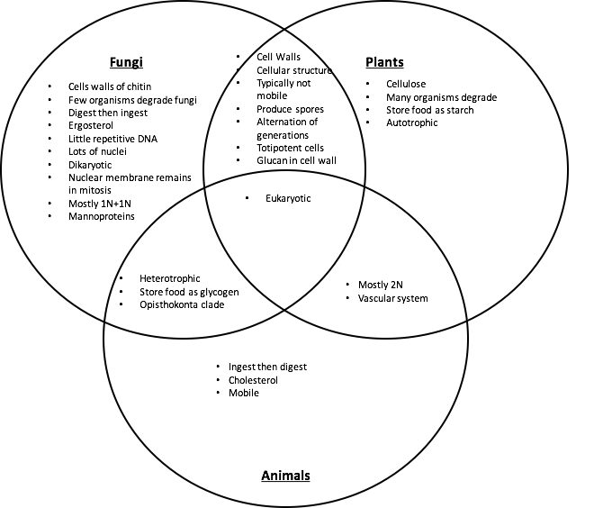
Figure 2.2. Venn diagram comparing similarities and differences of fungal, plant, and animal characteristics.

nuclei, even when two (or more) genetically unique nuclei coexist in an individual. Karyogamy (nuclear fusion) resulting in 2n nuclei only occurs in certain cells within fruiting bodies. These 2n nuclei form preceding the sexual production of gametes via meiosis. Higher plants have relatively large nuclei that are often diploid in all cells except the gametes, pollen and ovules. This is similar to animals.
A structure that both plant and fungal cells produce, and which serves many of the same functions, is the cell wall. The cell wall permits both plants and fungi to form sturdy structures capable of above ground growth by adding rigidity to tissue. Cell walls also assist in growth through physical substrates by permitting turgid fungal hyphae and plant tissue to exert outward osmotic pressure without the cell membrane rupturing. This is a crucial factor for the apical growth of hyphae among fungi through a physical substrate (Money, 1995), as it is in root tips and pollen tubes among plants. Additionally, cell walls serve to protect the cellular components and organelles found within. Despite similarities in function, the composition of the cell walls fundamentally differs between plants and fungi. Plants have cell walls composed of cellulose (and sometimes lignin) whereas fungi have cell walls of chitin.

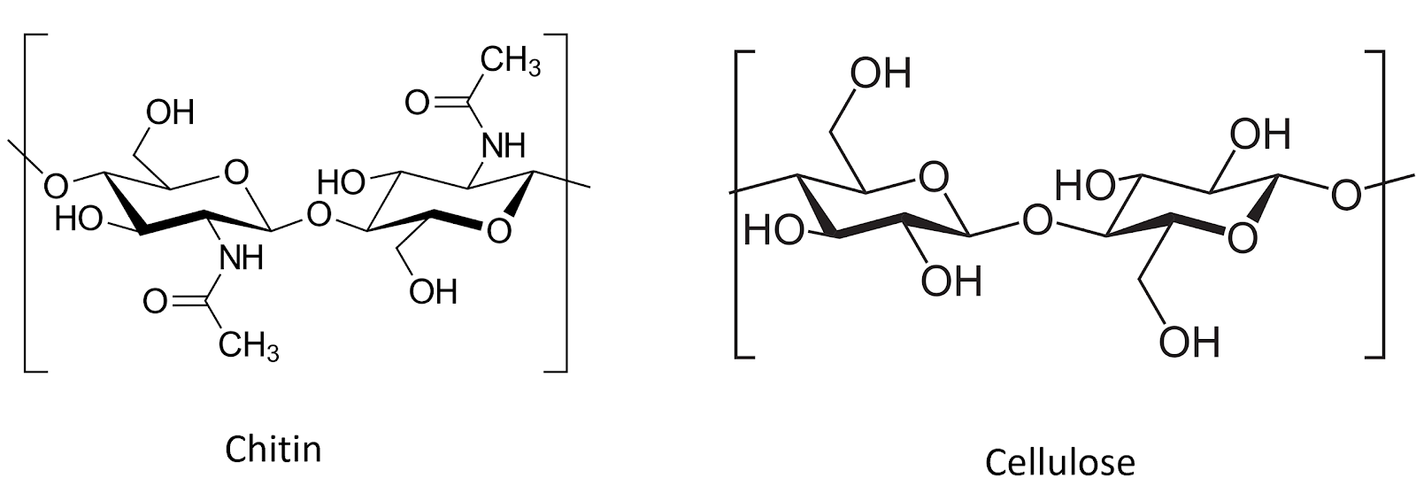
Figure 2.3. Chitin and cellulose are both polysacharide chains of β1-4 linked monosacharide monomers. Chitin comprises chains of N-Acetylglucosamine monomers, whereas cellulose is made of D-glucose monomers (graphic from wiki commons).

Due to the rigidity of the cell walls, both plants and fungi are generally sessile (non-motile) when mature. As sessile organisms, the lifestyle of plants and fungi are much different because of how each must acquire food. Plants are photoautotrophic and therefore able to produce their own food by utilizing sunlight energy to fix atmospheric carbon via photosynthesis into sugars. They also rely on root systems to gather essential elemental nutrients from the medium in which they grow. Plants metabolize sugars via cellular respiration as a source of stored energy. They also use the sugar they create, along with elemental nutrients from the soil, as substrates to synthesize the complex organic compounds their bodies require to live. In contrast, heterotrophs are unable to produce their own food and must acquire nutrition and carbon from the consumption of other organisms or their byproducts.
Fungi are chemoheterotrophic, meaning they must acquire organic carbon (rather than inorganic carbon dioxide) from the environment. These acquired nutrients serve as both their source of chemical energy and the necessary substrates from which their cellular machinery and bodies are produced. They are entirely reliant on acquiring nutrients and food from the environment.
Ultimately, all of every* fungus’s food is directly or indirectly sourced from carbon based molecules produced from the fixation of atmospheric carbon dioxide (CO₂) by plants. The same is true for ourselves as humans, as well as every other heterotrophic organism (save those lifeforms whose food is derived from the action of prokaryotic chemoautotrophs, such as the extremophiles which survive in sulfur springs or form the basis of the food webs of deep sea vents.).
*Of course “every” implies an absolute term. Biology resists absolutes and every rule will turn out to have exceptions. For example the “central dogma” of molecular biology included the word dogma because, Francias Crick when naming his hypothesis, considered the word to mean a belief for which there was no supporting evidence
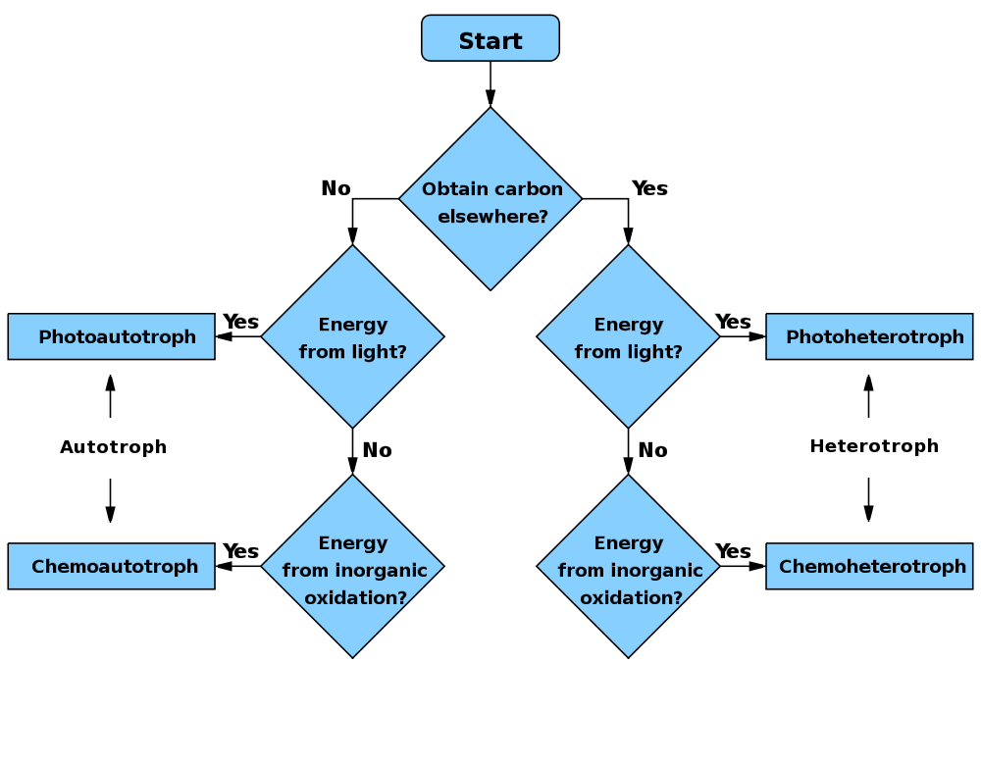
Figure 2.4. Flow chart comparing autotrophic (make their own energy source vs heterotrophic (must service carbon energy from outside of organism). WikiCommons user: Wickey-nl

While fungi are generally ‘non-motile,’ their cells are connected in such a way as to allow much of the cytoplasmic contents to flow through the tubular hyphae. In this way, a fungus can transport nutrients around its mycelium. While a fungus cannot move its existing body to a new location, they are able to exploit cytoplasmic flow in order to change or expand locations by growing hyphae in new directions, flowing their cytoplasm into the newly formed mycelial body, and walling off older sections of their mycelium. Thus, they may gain functional motility beyond that of most plants, despite lacking moving appendages with musculature, and while maintaining a rigid cell wall which prevents ameboid movement via pseudopodia (although some yeasts can move in this fashion).
Another implication of being unable to move is that fungi, like plants, cannot evade predators. Therefore, they are forced to come up with alternate defense mechanisms. Plants can develop thorns and spikes as part of their physical structure to discourage predators from attacking, however, they also produce a variety of novel secondary metabolites that act as defense compounds. Some fungi have developed physical defense structures, such as lacticifers among Lactarius or the physical toughness of many perennial polypores, but the production of secondary metabolites to ward off competitors or predators is ubiquitous. Some of these compounds include famous antibiotics, such as penicillin and its derivatives, or citric acid , a common food additive that is produced from Aspergillus niger fermentation. The plethora of secondary metabolites from fungi is astonishingly diverse and includes varying polyketides, terpenoids, terpenes, alkaloids, and peptides (Keller et al, 2005).

Animals and Fungi
There are a number of other key similarities and differences in plants and fungi, however, fungi are actually closer to animals than plants (Figure #2.2). Animals, plants and fungi are all eukaryotic, with DNA contained in a nuclei and membrane-bound organelles, representing their common lineage. However, plants split away from the ancestors of fungi and animals first. Today, fungi and animals are both placed within the clade Opisthokonta. A common trait of this clade is mobile gametes at some point in the organisms’ lifecycle. Only the basal lineages of fungi have retained motile gametes, as have humans (sperm). Most fungi no longer produce flagellated gametes.
Obviously, most animals are mobile organisms that are adept at moving around to find nutrients and food, and evade predators. The lack of cell walls is important for permitting contraction and relaxation of muscle cells, on which animal movement depends. The relative rigidity of mature fungal cells conferred by cell walls prevents contractile-relaxation of tissue, as well as ameboid-like formation of pseudopodia.
Both animals and fungi are chemoheterotrophic. In general, neither can produce their own food and cannot use light as an energy source. Thus, animals will ingest and then digest their food, whereas fungi digest (by releasing exoenzymes into the environment) and then ingest (by actively transporting nutrients back into the fungal body). An exception to this is that various animals, such as members of the Sacoglossan sea slugs, can become photosynthetic by sequestering entire photosynthetic microbes -or even just their chloroplasts (a phenomenon known as kleptoplasty). The animals may then acquire the ability to derive energy from photosynthesis.
A physiological difference with practical implications between fungi and animals is the structure of sterols embedded in their cell membranes. Fungi synthesize ergosterol whereas animals synthesize cholesterol (plants also produce a diverse array of phytosterols). Both ergosterol and cholesterol are derived from the same precursor, lanosterol (Fig. #2.5). Ergosterol and cholesterol serve similar functions including impacting membrane fluidity, cell signaling and other physiological processes.
One reason we are focusing on this particular molecular difference between fungi and animals is that we can exploit the ergosterol pathway unique to fungi in order to develop and apply selective fungicides. Compared to prokaryotic pathogens and disease agents, parasitic and pathogenic fungi have much more in common physiologically with their eukaryotic plant and animal hosts. Therefore, ergosterol and its biosynthesis are particularly important targets for antifungal compounds in agriculture, as well as veterinary and human medicine.
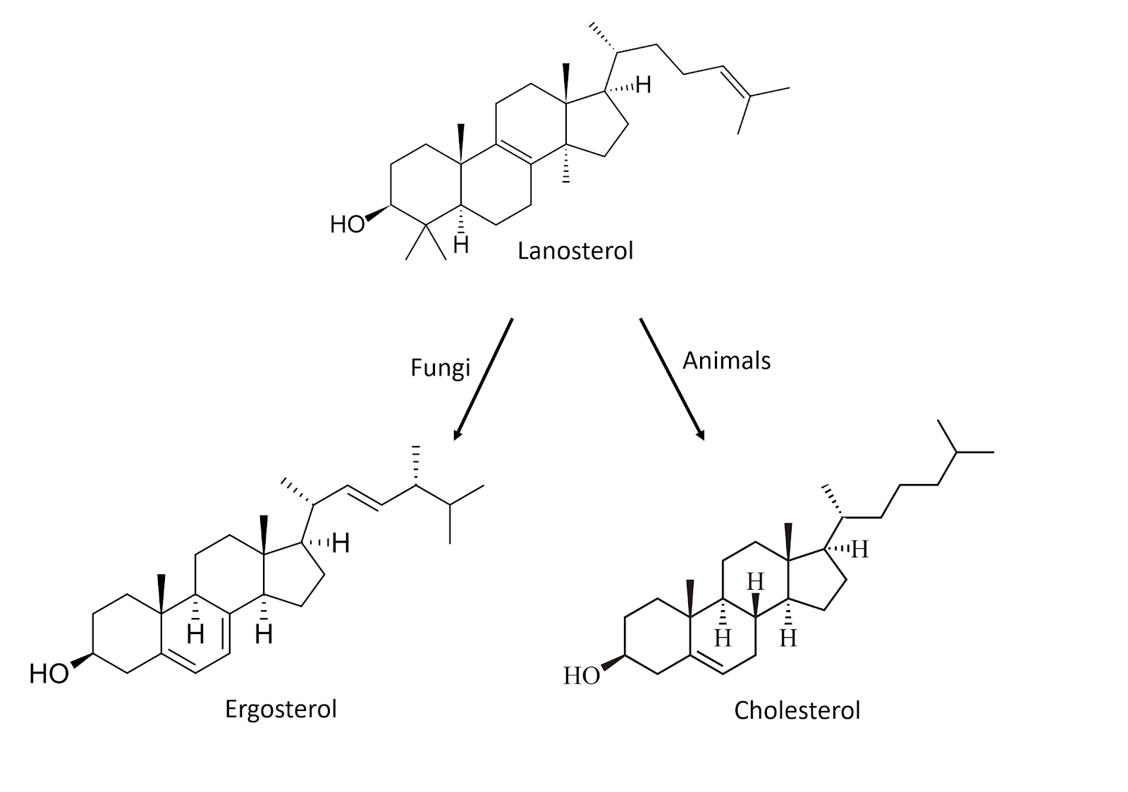
Figure 2.5. Chemical structures for sterol compounds found in fungi (Ergosterol) and animals (Cholesterol)

Fungi are an extremely unique and diverse group of organisms that contain some characteristics not found anywhere else in nature. The varied growth forms are reliant on external digestion of substrate by secreted exoenzymes, followed by ingestion of the predigested food via absorption and endocytosis. That fungus can be mono- or dikaryotic, some with many nuclei per ‘cell,’ is not only fascinating, but allows fungi unique physiological and evolutionary paths compared to uninucleate organisms.
Also, among filamentous fungi, cells can behave a little differently than one usually thinks of when considering traditional biological cell; the entire vegetative body, the mycelium, can exist as a complex network which nevertheless functions as though it is a single cell due to the ability of its cytoplasm to flow freely. Yeast cells are more akin to what most people think of when pondering single-celled organisms.

In summary:
· Fungi reproduce via spores
· Fungi are a distinct lineage from both plants or animals, though are closer related to animals than to plants
· Fungi have cell walls that are chemically different (composed of chitin) than the cell walls of plants (composed of cellulose)
· Fungi do not produce their own food so must release enzymes to break down complex food sources and the reabsorb the nutrients

Chapter 3.

Fungal Growth

This chapter will describe how fungi grow and obtain nutrients and other resources from the surrounding environment. Fungi are unique organisms that have features not found elsewhere in biology. Therefore it is important as cultivators to understand how fungi grow in hope of encouraging growth of beneficial fungi while inhibiting the growth and presence of fungal pathogens.
There are two main types of growth forms that fungi display; filamentous and yeast. The body of filamentous fungi is made of thin, thread-like, typically cylindrical cells that are extensively branched called hyphae (sing. hypha). These cells allow filamentous fungi to penetrate through substrates. All of the hyphae from an individual fungus is collectively called mycelium (plural mycelia when referring to more than one fungal individual). The mycelium is the vegetative body of the fungus and is the necessary form for the filamentous fungi to collect nutrients and water.
Yeast are single celled fungi, usually spherical, that do not form hyphae. Some fungi can take on a yeast or a filamentous form, depending on the growth stage and environmental conditions. Fungi capable of this versatility in form are referred to as dimorphic.
Yeast forms exist as single cells that replicate via budding or fission, creating two exact genetic copies of itself from a single mother cell. In this way, vegetative growth in yeast is characterized by asexual reproduction of individual cells, rather than growth of a single contiguous hyphal body. Many yeast can also reproduce via sexual replication. Yeast fungi are quite ubiquitous, albeit underappreciated, especially in agriculture settings

Filamentous fungi
Filamentous fungi eat and grow simultaneously. They do so by releasing enzymes ahead and out of the growing hyphal tip, then pushing through their food as they consume it. To coordinate the release of enzymes, filamentous fungi have an organelle-like structure that is called a spitzenkorper at the tip of growing hyphae. This microtubule-dense organizational center delivers vesicles full of enzymes directly outside the growing fungal tip. This external enzyme bath breaks down complex materials into more fundamental, nutritive molecules which are then accessible for endocytosis or direct absorption by the fungus (Steinberg 2014). Additionally, the breakdown of solid substrates clears a path for physical growth of and occupation by the fungus.
Once inside the hyphae, molecules are further broken down and metabolized by the fungus for all of its life functions and growth, including synthesizing proteins, cell walls, hormones, etc.. This is how a fungus ‘eats’, consumes resources, and grows. As the keen mycologist Tom Volk often explains, “it would be as if I went to a 5 star restaurant and ordered the surf and turf (or tofu surprise) and then when the meal came I vomited all over the dish and then stuck my hands over the mess to absorb the nutrients back into my body.” Quite the image.
Another physical trait that some filamentous fungi possess is having septa. Septa are crosswalls that some fungi produce behind the growing tip in order to divide the hyphae into different ‘cells’. These septa are perforated, allowing some organelles to pass while blocking others. Because many groups of fungi allow the movement of so much of their cellular contents, sometimes including nuclei, the individuality of each cell isn’t always clearcut.
There are two different types of septa that are found in fungi; simple porate septa and dolipore septa. These different septa morphologies can be used to distinguish the phylum that the fungus is located in. Fungi in the phylum Basidiomycota have what is called a dolipore septum, often along with a clamp connection. This type of septum has membranes covering the central pores, allowing for the fungus to maintain its dikaryotic state (2 types of nuclei per cell) while still allowing small organelles and chemicals to flow through with the cytoplasm.
Septa are partitions between fungal cells, but in some fungi, these septa lack membranes that would typically block organelles, such as nuclei, from passing between cells. This allows for the free flow of organelles across cells. Some fungal groups, like Zygomycota (bread molds), Glomeromycota (endomycorrhizae), and Chytridiomycota (which includes the pathogen causing chytridiomycosis), lack septa altogether, or have them only occasionally, and are termed coenocytic or aseptate.
In coenocytic fungi, where there are no septa, the organism functions as a single, multinucleate cell. The hyphal tips, where growth is highest, often have a high concentration of nuclei, indicating a need for gene products in these areas. This cellular structure enables fungi to exchange nuclei and cytoplasm with compatible fungi, leading to genetic variation within a single individual. This type of genetic exchange provides fungi with phenotypic plasticity, enhancing their ability to adapt to their environment. It also serves as a source of genetic diversity, which can drive fungal evolution, especially in fungi that do not reproduce sexually. Such exchanges can even occur between distantly related fungal species, further contributing to genetic novelty.

Some filamentous fungi will produce a fruiting body collectively called a mushroom. A mushroom is simply a reproductive structure that certain fungi have evolved to produce. In general, edible mushroom producing fungi are not physiologically involved with Cannabis. However, some applications of mushroom producing species may be beneficial in Cannabis agriculture. For example, Pleurotus osreatus, the common oyster mushroom, can be cultivated on the dead biomass of Cannabis plants (the stems, the leaves). Another example of a mushroom producing fungus that aids in Cannabis cultivation is Stropharia rugosa-annulata or the garden giant (aka wine cap). This fungus is particularly good at decomposing organic materials such as wood chips or straw and is commonly inoculated in garden beds. In addition, planting mushrooms near cash crops also recruits other biology to the soil system. Using the garden giant will help aid in nutrient cycling, improve soil structure, and may release compounds that influence plants and/or soil biology. https://www.ncbi.nlm.nih.gov/pmc/articles/PMC4358370/
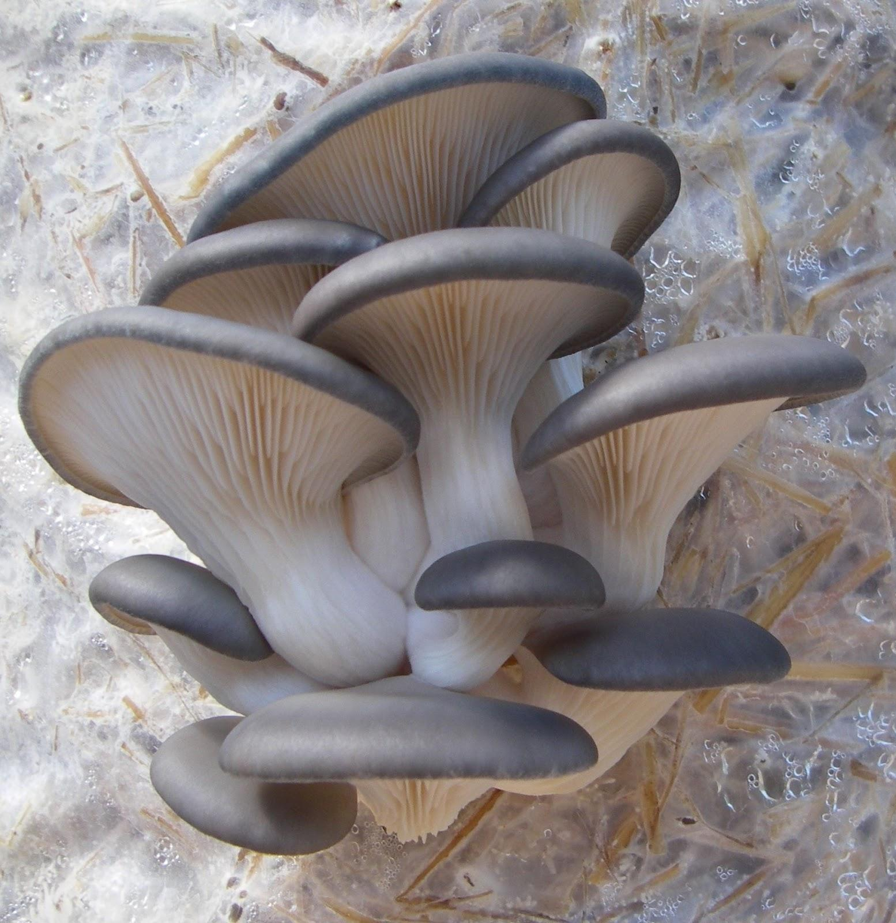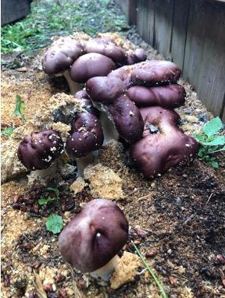
3.1a Oyster mushroom fruiting off straw. 3.1b Wine cap fruiting out of soil.

Currently there is some misinformation going around in the Cannabis industry in relation to soil fungi and compost tea. There have been claims by some who say that if a fungus has septa, then the fungus is beneficial and will help with decomposition and plant growth. However, if the fungus does not have septa (coenocytic), then it is a pathogenic fungus and will kill plants and harm your soil community. While there are some instances where this may be true, this is a broad over-generalization and septa alone should not be used to identify beneficial vs pathogenic fungi. Possibly, what people are referring to is Oomycetes, or water molds, which are coenocytic, pathogenic, and are also not true fungi. Many useful and beneficial fungi lack septation, including members of the Glomeromycota, and Zygomycota.

Yeast Fungi
Yeast fungi are single-celled organisms that are often too small to be seen without a microscope. They are found everywhere in various habitats across the globe. One of the most well-known yeasts is Saccharomyces cerevisiae, commonly used in brewing and baking. This species, with its various strains, has a long history of use by humans. Additionally, Saccharomyces cerevisiae is a valuable model organism for scientific research due to its ease of cultivation and resilience. However, not all yeasts are beneficial—some, like Cryptococcus neoformans, can cause serious diseases in humans, including cryptococcosis, and can also be endophytes of plants like Cannabis.
Yeasts are difficult to identify through simple observation under a microscope. While some may show unique physiological traits, many require metabolic testing or molecular techniques for accurate identification. Despite their small size and often unnoticed presence, yeasts play an important role in soil and agriculture. They help decompose organic matter, serve as a food source for other organisms, produce valuable metabolites, influence plant growth, and contribute to soil structure.
Conclusions
Fungi either grow as a unicellular yeasts, have a filamentous body of hyphae collectively called mycelium, or may switch between these forms. Filamentous growth offers certain advantages over yeast forms for the performance of particular tasks. The absorptive eating strategy employed by fungi benefits from a highly branched, fast expanding body with favorable surface ratio for the exploitation of an abundant food resource. As digestive enzymes released from the growing tip of the fungus, the hyphal body can absorb the products of the substrates decomposition via endocytosis.
Filamentous fungi may also differentiate into specialized structures and have complex patterns of nutrient transport and metabolic coordination. This can be particularly useful when claiming territory and food resources over long periods of time. Some filamentous fungi can grow perennial structures that persist and function for years and even decades. However, being small and simple in design has its benefits as well. Yeasts are capable of reproducing at an extraordinary rate. Because they are just a single cell, everything the organism needs to survive and reproduce is kept in every cell.
As you can see, fungi can be quite diverse in appearance both macroscopically and microscopically. While these differences have proven useful as diagnostic features for the identification and classification of organisms, the true utility of these features is to allow fungi to specialize and exploit various ecological niches. Now let us explore further how fungi live, grow, and gather nutrients from their environment.
In summary:
· Fungi can grow as a yeast or in a filamentous form, sometimes both
· Fungi do not produce their own food so must release enzymes to break down complex food sources, then ingest the predigested nutrients into their bodies
· Filamentous fungi grow from the apical tips to eat food and colonize new spaces
Chapter 4: Lifestyle

Fungal lifestyles are an important aspect of plant-fungi interactions which will determine a farmers relationship with each fungal species they encounter. Many fungi are helpful to farmers. Some serve to cycle nutrients from organic matter and access those trapped in parent rock material. Others colonize the surfaces and internal tissues of plants. Most of these relationships benefit their host plant in myriad ways, or at the least do not cause any apparent harm.
Often, the fungal lifestyle most familiar to farmers is one that manifests as a conspicuous loss of crop to disease. Disease causing fungi of Cannabis are those that live as pathogens, causing harm to their host plant in order to obtain nutrition from it. Understanding the different strategies of fungi found on your farm will allow more adept control over their manipulation so that pathogens may be minimized while beneficials can be optimized.
Fungi are heterotrophic, reliant on acquiring nutrients from the environment they live in for their metabolic demands. As such, fungi typically fit among three different types of lifestyles that they use to get nutrients. Those lifestyles are saprophytic (fungi that degrade dead organic material), parasitic (fungi that live on another living organism and cause the host some degree of harm) and mutualistic (meaning there are benefits to both the fungus and its symbiont). In addition to these lifestyles, there are some predacious fungi that derive all or part of their nutrients from carnivory; they do so by trapping soil inhabiting invertebrates using specialized hyphae. Many fungi readily switch roles among these trophic strategies from parasite, to mutualist, to saprophyte, to predator, and back again as it suits their needs and abilities.
Saprophytes are very important in all ecosystems because they are the ‘grand recyclers’ and utilize dead material to make locked up nutrients available for other organisms to utilize. Therefore, saprobes play an important role in nutrient cycling. This makes these fungi very important for organic Cannabis agriculture.
The garden giant (Stropharia rugosa-annulata) is one example of a fungus that is often incorporated into raised garden beds. The mycelium is mixed with pasteurized straw or wood chips and then used to cover the soil on the garden bed. This not only cools the soil surface temperature and reduces weeds, but it also cycles nutrients through the soil system to your plants. This occurs because fungi are constantly secreting enzymes that break down complex compounds into simpler molecules that can eventually be assimilated by the plants. The garden giant fungus is also relatively easy to grow outdoors and produces an incredibly tasty mushroom, making it a perfect companion for outdoor plantings with Cannabis.
Other saprophytic soil fungi may benefit plants similarly, as well as improving nutrient cycling, soil structure, water retention, recruiting other biological organisms, and competing with disease agents. Make note that care should be taken to ensure adequate nitrogen availability when adding low nitrogen, high carbon mulch material; in the short term, nitrogen will be pulled from the top layers of the soil by saprophytes as they colonize and degrade new mulch.
Other saprophytic fungi include edible, mushroom-producing fungi such as oyster mushroom, shitake mushroom, and button mushroom. Many soil fungi, including Trichoderma and Penicillium species, are saprophytes that do not produce mushrooms but play key roles in the conversion of organic matter into usable nutrients. If your soil lacks fungal diversity, high quality compost or compost extracts are full of soil microorganisms and is an efficient method for inoculating fungi back to soils.
While saprophytic fungi grow on dead organic matter, parasitic fungi grow on living organic matter. Parasitic fungi can grow on many different organisms, ranging from animals to plants, to even other fungi (Fig 4.1). By definition, parasitic fungi are fungi that derive their nutrients from another living organism with no apparent benefit to the host. Because parasites require a living victim to persist, a well-adapted and specialized parasite rarely kills its host. There are some fungi that act as human pathogens and can cause serious illness, especially in patients that already have a compromised immune system. For instance, athlete's foot and ringworm are both diseases which affect humans that are caused by fungi in the genus Arthroderma. Then there are a lot of other
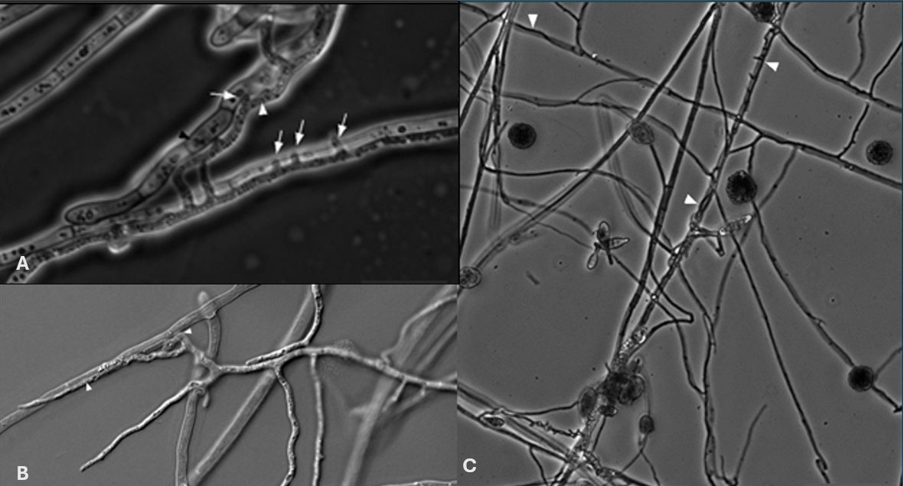
Figure 4.1. An example of a mycoparasitic interaction where Alternaria alternata is attacking the hyphae of Eppicoccum nigrum seen with phase (A and B) and differential contrast interference (C) microscopy.

fungi that act as pathogens to plants. Some of these species of fungi are generalists and can live on a variety of host plants, whereas other species are specialists, growing only on specific host plants. For the Cannabis plant, there are a variety of fungal species that can act as pathogens and they range in the amount of damage to the host (Table 4.1).
Though there are a number of fungi that act as parasites, there are also many that have beneficial relationships with other organisms. This type of symbiosis, where two organisms interact physiologically to form a mutually beneficial relationship, is called mutualism. For example, a lichen is a mutualism where a fungus acts as a mycobiont and an algae or cyanobacteria will act as a photobiont; together they create one organism, a lichen. Another example of this is mycorrhizal fungi. Mycorrhizal (myco- meaning fungus and -rhiza meaning root) fungi form associations with the roots of many different plants and help deliver the plant water, minerals, and nutrients (in particular phosphorus) and in return the plants gives the fungus sugars that it makes in photosynthesis.
Table 4.1. A few of the many important saprophytes, parasites, and mutualists for Cannabis growers
Saprophytes | Parasites | Mutualist
Soil:  - Penicillium spp.  - Aspergillus spp.  - Trichoderma verde  - Trichoderma hazarium  Wood Rot:  - Pleurotus spp.  - Stropharia rugosoannulata  - Pilocybe spp. | Plant pathogens  - Fusarium oxysporum  - Botrytis cinerea  - Golovinomyces ambrosiae  - Podosphaera macularis  - Septoria cannabis  - Alternaria alternata  Mycoparasitic  - Trichoderma verde  - Trichoderma hazarium | Arbuscular (Endo-) Mycorrhizae:  - Glomus spp.  - Rhizophagus intraradices  - Funneliformis mosseae  - R. irregularis  Mucormycoitina Fine Root Endophytes  - Planticonsortium tenua  Endophytes  - Penicillium spp.  - Trichoderma spp.

A fourth type of interaction that we see fungi engage in is called commensalism. This is when one organism uses another organism to its benefit, without causing harm to the other organism. An example of this is when an epiphytic orchid is growing high up in the crevasse of a tree, the orchid has an advantage over other orchids because it is higher up and therefore is closer to sunlight, whereas the tree is not meaningfully affected positively or negatively.
Although these four different types of relationships or lifestyles may seem clearly defined, realistically in nature these relationships are on a continuum. These four different lifestyles that we just described (Saprophyte, parasite, mutualism and commensalism) are all terms that were created by humans to help us understand nature. However, nature is not confined to such borders and therefore we see some organisms that are mutualists at one point in their life, and then they switch to being a parasite, and eventually they act as a saprophyte because the organism is consuming the dead host that it just parasitized. So, although we do our best to describe and make sense of nature, we always have to remind ourselves that nature doesn't always follow our rules.
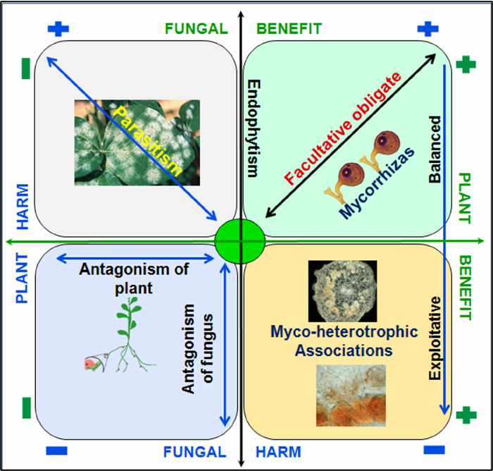
Fig 4.2 Plan-fungus symbiosis continuum spectrum; upper right is where both partners benefit, upper left the fungus is benefiting but the plant is being harmed (parasitism), lower right is where plants benefit but the fungus has reduced fitness, lower left depicts a relationship where neither partner is benefiting.

In Summary:

- Saprophytic fungi degrade dead organic materials
- Mutualistic fungi live in symbiosis with another organism where both members are benefiting
- Commensal symbiosis is when 2 organisms live together and only 1 partner is benefiting but the other partner is not harmed in any way
- Parasitic fungi steal nutrients from a living host organism

Chapter 5
Fungal Taxonomy and Systematics

Taxonomy and systematics refer to the naming and relative relationship of any biological organism. Here we discuss how fungi are classified, named and, more importantly, how this system is changing and can be a source of confusion for the non-academic, farming community. This information will prove useful if trying to protect crops against particular pathogens and also for determining how closely one fungus is related to another. In particular, when trying to find a treatment (biological, chemical, or environmental) to reduce pathogen infection of a Cannabis crop.
Science has attempted to classify organisms in a hierarchical way, in order to help organize and make sense of nature. All extant organisms on earth that we know of have descended from a common ancestor, known as the last universal common ancestor (LUCA). Scientific systematics reflects the relation of organisms to other groups through this classification system. We can use this classification system to tell us some similarities and relatedness of fungi to other organisms in general terms.
The hierarchical classification follows the same arrangement for all living organisms. This classification begins with the most broad groupings of relatives, and gets more and more specific with every step of the way. As such, all organisms are sorted into one of three domains, then into clades, followed by kingdom, phylum, class, order, family, genus and, finally, species. Together, we may compile all of this information to create a ‘tree of life’ which helps us visualize the relatedness of all organisms. This tree contains all life on earth, from single-celled bacteria all the way up to the most evolutionarily derived organisms, including ourselves -Homo sapiens (Fig. 5.1).

Table 5.1. Hierarchical classification of some commonly encountered fungi
Kingdom | Fungi | Fungi | Fungi | Fungi | Fungi
Phylum | Basidiomycota | Mucoromycota | Mucoromycota | Ascomycota | Ascomycota
Subphylum |  | Glomeromycotina | Mucoromycotina
Class | Hymenomycetes | Glomeromycetes | Incertae sedis | Sordariomycetes | Leotiomycetes
Order | Agaricales | Glomerales | Incertae sedis | Hypocreales | Helotiales
Family | Agaricaceae | Glomeraceae | Incertae sedis | Hypocreaceae | Sclerotiniaceae
Genus | Agaricus | Glomus | Planticonsortium | Trichoderma | Botrytis
Species | Agaricus bisporus | Glomus  mosseae | tenue  mosseae | Trichoderma  viride | Botrytis  cinerea
Common Name | portabello, crimini, button mushroom | arbuscular mycorrhiza,  endomycorrhiza | Mycormycotina fine root endophytes | Green mold | Grey mold, bud rot

Classification has generally been rooted in a concept of the ‘vertical’ transmission of heritable traits from parent to offspring, with lineages diverging over time as evolution imposes separations among populations of living beings. However, genes do not only move from parent to offspring. Genes may also move sideways during an individual's lifetime, or ‘horizontally’, and do not necessarily originate from a relative or even member of their own species. The result is a tree of life that has many fused branches which depart and recombine over time. For this reason, some modern biologists eschew the tree analogy for something more akin to a web (Doolittle, 2000). Horizontal gene transfer is particularly common at the ‘base’ of the tree among the prokaryotes.
Some scientists estimate that there may be somewhere around 5 million species of fungi in the world, about 70,000 of which have been described (Blackwell, 2011). Regardless of how many species of fungi there are, what we do know is that fungi are a very diverse group of organisms that are ubiquitous in nature. We still have much to learn about this fascinating Kingdom.
As we begin to attempt to identify different types of fungi, it is important to keep in mind what makes all fungi similar and also what makes a button mushroom different, from say, a morel mushroom. Macroscopically there are some clear differences. However, with the help of a microscope, there are features that easily separate out many of the various phyla of fungi. This will help out immensely when attempting to identify moldy fungi. Some fungi obscure their true identity from observers attempting to utilize physical features alone and require genetic study to differentiate.
The scientific names of species, known as their specific epithet, consists of the two most restricted levels of the categorical titles mentioned: genus and species. This naming system is referred to as binomial nomenclature and was pioneered by Carl Linnaeus; the same person who pioneered the hierarchical classification system. Linnaeus, working a century before the Theory of Evolution was to be elegantly described by Charles Darwin and Alfred Russel Wallace, was of the contemporary opinion that species were immutable and unchanging from their original creation. Therefore, Linnaeus's classification system was a taxonomy, concerned only with the naming of organisms, while grouping together those that appeared similar for ease of categorization.
Modern taxonomy now incorporates the Theory of Evolution to include not just diagnostic features of species phenotypic expressions, but also the relatedness of species, or its phylogeny, through time. This synthesis of taxonomy and evolutionary relatedness has resulted in the field of systematics.

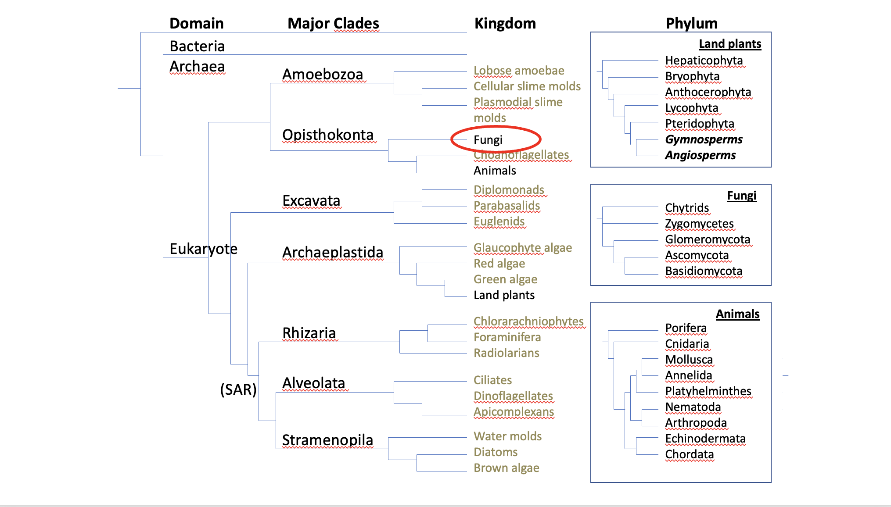

Figure 5.1. Example of a basic tree of life.

Depending on which classification scheme you read, there are 5-18 phyla in the Kingdom fungi. For our discussions, these include Basidiomycota, the club fungi; Ascomycota, the sac fungi; Mucoromycota (formerly ‘Glomeromycota’ and ‘Zygomycota’); Chytridiomycota, the mobile ‘little pot’ fungi; and finally the Microsporidia, unicellular parasites formerly thought to be non-fungi protists. The ‘Zygomycota’ have been discovered to be a polyphyletic grouping (not descended from an immediate common ancestor) and is no longer formally recognized as a phylum (Hibbet et al 2007, Spatafora 2016, Tedersoo et al. 2018). The term is still in popular usage and will serve as a useful grouping in this book. Similarly, ‘Glomeromycota’ was the former name of the Glomeromycotina, a subphylum in Mucoromycota (Bruns et al. 2017).
Ascomycota is home to many soil decomposers, ectomycorrhizal species, most plant endophytic fungi, as well as most of the dreaded plant and human fungal pathogens. Basidiomycota contains most of the species people recognize as ‘mushrooms;’ they often are responsible for primary decomposition of woody materials, though many form ectomycorrhizae with woody plant species and some species cause plant and human disease. The Mycoromycota comprise the arbuscular mycorrhizal fungi in the Glomeromycotina, in addition to the ‘Zygomycota’ fungi such as bread molds, post-harvest strawberry mold, as well as the newly transcribed Mucoromycotina Fine Root Endophyte mycorrhizae (Orchard et al 2016). Chytridiomycota (as well as bacteria and archaea) also assist in the breakdown of cellulolytic, lignin, chitin, and keratin based materials.
Although people have been studying and attempting to classify fungi for hundreds of years, fungal systematics is in a state of constant flux. Scientists and researchers frequently go back and forth on where certain fungal organisms belong on the tree of life. With the advancement of various molecular techniques, we are able to better estimate the relatedness of different fungi. However, molecular techniques themselves develop over time as our understanding increases, as does our understanding of how to interpret the resulting data. It is important to remember that these classification systems are our best current understanding of these organisms’ relatedness in nature. Current classifications are not sacrosanct. The names of species and our understanding of their placement on the tangled tree of life still change frequently.
With that in mind, we must accept that some fungi that we now know by certain names may be given a new name in the upcoming years. The result of these frequent name changes is that technically-defunct names for fungi may remain in circulation as synonyms, particularly for fungi that were widely known by names based on old taxonomic classifications. A prime example is the endomycorrhizal fungus Rhizophagus irregularis. Two decades after its official name change, this agriculturally-important fungus is still widely marketed under its defunct, but more popularly recognized name, Glomus intraradices. Keep this in mind as you learn fungal species names (see Index Fungorum at indexfungorum.org for up to date scientific names and listings of previous synonyms).
The two phyla to which all mushroom-producing fungi belong are the Basidiomycota and Ascomycota. In Basidiomycota, spores are borne-exterior, on a club-shaped structure called a basidium, typically in groups of four, whereas in Ascomycota, spores are developed inside a sac-like structure called an ascus, typically in groups of eight spores. Throughout our journey with mycology, we will see time and time again the spores and spore-bearing structures will aid in identification.
Fungal phyla:
Basidiomycota: These fungi, which include many mushrooms, mostly act as decomposers, breaking down organic material like crop residues and wood. While they’re not huge plant pathogens, some species can affect Cannabis, such as Rhizoctonia (which causes damping off and other root diseases) and Aecidium cannabis (a rust fungus). Basidiomycota have specialized structures called basidia which produce spores, often seen on the gills or pores of mushrooms.
Ascomycota: This group includes molds like Trichoderma, Aspergillus, and Penicillium. They’re commonly found in soils with organic matter. These fungi typically reproduce via spores inside special sacs and can live in different environments, including as symbionts, decomposers, or pathogens. They’re often unnoticed because many reproduce asexually.
Glomeromycotina: These fungi form symbiotic relationships with plants, including Cannabis, by attaching to their roots. They create structures that help plants absorb nutrients (like phosphorus) and water, while the plant provides them with sugars. This relationship is particularly helpful in nutrient-poor soils. These fungi reproduce via spores, and while their sexual reproduction isn’t well documented, they might have some form of it.
Mucoromycota & Zoopagomycota: Formerly grouped as Zygomycota, these fungi have been split into two groups. Mucoromycota are mainly soil saprophytes and occasionally pathogens (like the mold on bread). They can form symbiotic relationships with plants but also cause issues for crops like strawberries. Zoopagomycota are mostly parasitic, attacking insects. Some members are used as natural pest control. These fungi reproduce via specialized structures and can even self-fertilize in some cases.
Chytridiomycota: These aquatic fungi are some of the most ancient, and they have the unique ability to swim using flagellated spores. While most chytrids affect small organisms like algae or amphibians, some plant diseases, like potato wart, are caused by them. They’re generally more useful as decomposers and help break down tough materials like chitin. Some chytrid species have even been found on Cannabis, though we don’t fully understand their role yet.
In general, these fungi play important roles in nutrient cycling, plant health, and sometimes crop diseases. Their interactions with Cannabis are still being studied, so there may be more to discover.
‘Deuteromycota’
The ‘Deuteromycota’ are an artificial grouping of filamentous fungi that exist in the asexual (anamorphic) state. This superficial grouping is useful for characterizing these organisms based on form and function. Prior to the invention of molecular techniques, fungi were primarily classified based on their sexual structures. However, since certain fungi did not produce sexual reproductive structures in vitro , scientists were unsure which group to place these organisms in. Therefore, mycologists created a new group for the ‘imperfect fungi’ named deuteromycota.
Most of these species are Ascomycota, though Zygomycota and Basidiomycota also may be classified as ‘Deuteromycetes.’ Many of these fungi cause disease in animals and plants, therefore creating a giant economic impact.
Again, this classification scheme is based solely on morphological features and mainly the lack of reproductive structures. Therefore this grouping does not indicate the true genetic relatedness of these fungi but is still useful for relaying information about the organism's physical features. Many mycologists still use this classification method out of ‘convenience and tradition’ (Volk 2013).
The non-fungi:
Oomycota: Even though they’re called “water molds,” these organisms aren’t actually fungi. They belong to a completely different group called Heterokonts, and they’re more closely related to algae (like kelp) than to fungi. Oomycota have filamentous structures similar to fungal hyphae, but their cells don’t have septa. They reproduce with mobile spores (zoospores) and resting spores (oospores). Some species, like Pythium, are a problem for Cannabis farming, causing damping off in seedlings. However, some oomycetes, like Pythium oligandrum, are beneficial because they can act as biocontrol agents, fighting off harmful soil pathogens like Rhizoctonia and Botrytis.
Actinobacteria: These are gram-positive bacteria that form filamentous networks, which makes them look a bit like fungi. However, they’re not fungi at all—they’re prokaryotes. These bacteria can decompose organic matter, fix nitrogen, and thrive in low-oxygen environments. A well-known example is Streptomyces, which produces antibiotics and is important in agriculture. They’re often responsible for that earthy smell you get after rain in forests, and they can be found in hot compost piles. Even though they were once thought to be a "missing link" between fungi and bacteria due to their fungal-like growth, molecular research has proven they are distinct from fungi.
So, while oomycetes and actinobacteria may resemble fungi in some ways, they have their own unique roles and relationships in nature.
In summary:
- Taxonomy and classification is important to show how related different organisms are to each other
- Fungi are eukaryotic organisms closer related to animals than to plants
- 5 major phyla in kingdom fungi are Basisiomycota, Ascomycota, Glomeromycota, Zygomycota, and Chytridiomycota
- Fungal taxonomy is in a state of constant flux
- Water molds and slime molds are not true fungi

Chapter 6
Fungal reproduction

One of the reasons why fungi are so successful and therefore so ubiquitous in nature is due to their mode of reproduction: spores. Most species of fungi can produce spores in incredible quantities. The ability of fungi to produce so many spores increases the chance that at least some of them will land in a suitable environment where they can germinate and begin the process all over again.
Spores can be a result of sexual reproduction, involving meiosis and genetic recombination. Or they can be produced asexually, where genetic clones of the parent are produced via mitosis. Some fungi produce only sexual spores or only asexual spores (conidiospores), while others may be capable of both sexual and asexual spore production.
Spores also vary quite drastically in shape and size. As a matter of fact, spore shape/size/features/colors/staining-ability are often extremely useful tools in identifying fungi. Characteristics relevant to spore development on the reproductive part of the fungus can be another useful tool in identifying unknown fungi.
Similar to the importance of flower and reproductive morphology for identifying plants, the reproductive parts of fungi often reveal evolutionarily-conserved, diagnostic features that are more readily differentiated than vegetative tissue. The characteristics of reproductive tissue are less likely than vegetative tissue to change drastically through evolutionary time. This is likely because the precision of reproduction, and therefore its relevant tissues, are so fundamental to survival of a species across generations. Vegetative structures, on the other hand, may be more flexible to change in the face of shifting selective pressures due to the wider range of acceptable functionality of such tissues. Therefore, vegetative characters often appear similar, even among relatively unrelated organisms; an artifact of convergent evolution.

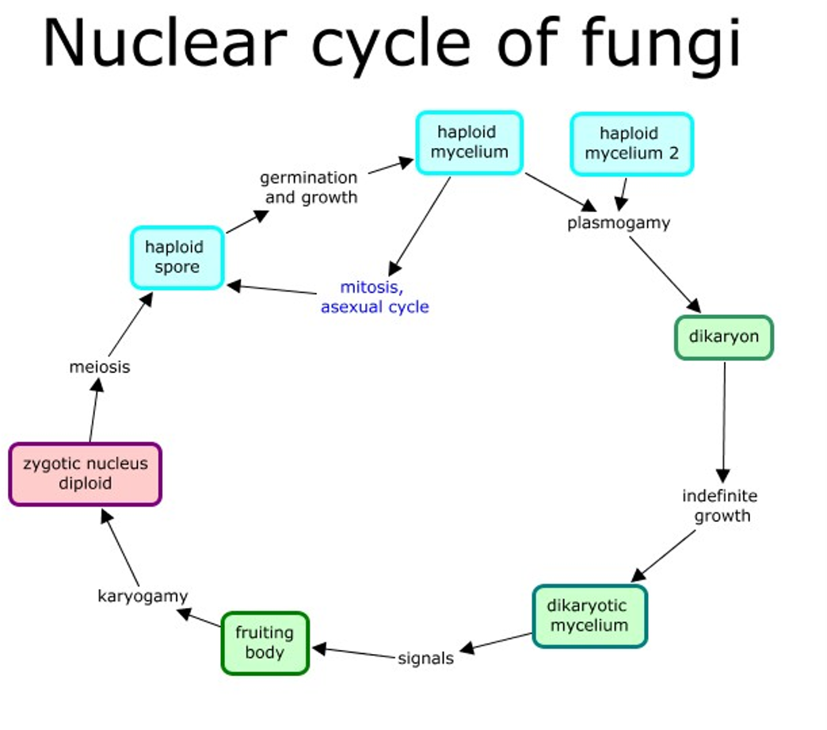
Figure 6.1. General life cycle of fungi. From Tom Volk

All fungi begin life as a spore (Figure 6.1). The spore can then germinate into either a hypha or a yeast, depending on the species. For some dimorphic species (capable of growth as a yeast or a filamentous mycelium), environmental interactions will determine their growth form. If filamentous, the hyphae will grow, secreting extracellular enzymes (exoenzymes) into their environment, allowing the fungi to penetrate and grow through substrate, in three dimensions. Most fungi that grow from spores possess genetically uniform nuclei (an exception to this may be the multinucleate spores of the Glomeromycota). When a hypha has only one type of nucleus in the cell, it is called monokaryotic.

Homothallism and Heterothallism
Heterothallism: These fungi need another individual to mate with sexually. When two compatible hyphae (fungal threads) meet, they fuse, and their nuclei combine, but each keeps its own genetic material. This results in a dikaryoticmycelium (with two separate, genetically distinct nuclei). When the environment signals, the two nuclei fuse (karyogamy), and sexual reproduction takes place, creating spores with a mix of genetic material from both parents. This process encourages genetic diversity. Heterothallic fungi can also reproduce asexually to spread quickly and find a mate when needed.
Homothallism: Fungi that are homothallic can mate with themselves, meaning they don’t need another individual for sexual reproduction. The process is similar to heterothallic fungi in that the nuclei fuse and then undergo meiosis to create sexual spores. However, self-mating reduces genetic diversity compared to mating with a different individual. This can lead to more uniform offspring, which could be beneficial in stable environments, but it may limit the fungus’s ability to adapt to changes or new challenges.
Benefits and Drawbacks:
- Heterothallic fungi get more genetic variety by combining the genomes of two different individuals, which helps them adapt and evolve. But they need to find a mate, which might be tricky in some environments.
- Homothallic fungi, on the other hand, can reproduce alone, which can be an advantage in environments where mates are scarce. But, because they’re reproducing with themselves, they don’t get as much genetic variation, which might make them less adaptable.
Dikarya is a group made up of Basidiomycota and Ascomycota (which includes many molds). The key feature of these fungi is the dikaryon stage. This means that after two compatible haploid (1n) individuals meet and fuse their cell membranes (a process called plasmogamy), their nuclei don’t immediately fuse. Instead, the two nuclei stay separate for a while, and this results in a dikaryon (n+n), meaning there are two distinct nuclei in the same cell. This is different from other organisms in the Opisthokonta group, like humans, where after plasmogamy, the nuclei fuse right away to form a diploid (2n) cell.

Basidiomycota
In Basidiomycota, the life cycle starts with a haploid spore that grows into a haploid hypha. For heterothallic (needing a mate) fungi, these hyphae will search for a compatible partner. When they find one, the hyphae fuse (called plasmogamy), but instead of combining into one single nucleus right away, the nuclei stay separate, creating a dikaryoticstate. This means there are two genetically distinct nuclei (n+n) in each cell, and this state is maintained by a dolipore septum—a kind of "gatekeeper" that prevents the nuclei from mixing.
As the hyphae grow, the fungus waits for the right environmental conditions to form a fruiting body (also called a basidiome), which is what we recognize as a mushroom. In the fruiting body, specifically in the lamella (the gills of the mushroom), the two nuclei finally fuse to form a diploid zygotic nucleus. This is the only diploid stage of the lifecycle. After this, meiosis happens, resulting in four genetically unique daughter nuclei. These become spores that are released from the tips of basidia (the club-like structures on the gills). Some Basidiomycetes can also reproduce asexually, creating spores without needing a mate or forming a fruiting body.

Ascomycota
In Ascomycota, the life cycle begins similarly with a haploid spore that grows into mycelium. For heterothallic species (again, needing a mate), when compatible hyphae meet, they fuse to create dikaryotic hyphae. Ascomycetes form septa(walls between cells), but unlike Basidiomycota, their septa have pores that allow the movement of nuclei and organelles. This results in a lot of nuclear movement, especially in the growing tips of the hyphae.
For sexual reproduction, specialized structures called ascogonium and antheridium form. The antheridium transfers nuclei into the ascogonium, and the two nuclei eventually fuse (karyogamy), creating a diploid zygote. This zygote undergoes meiosis, producing four unique nuclei. These then divide again by mitosis to form eight spores in a specialized cell called the ascus (plural asci).
Ascomycota also produce asexual spores, which are more common and are produced via mitosis. These spores (called conidia) are haploid and are made on specialized structures called conidiophores (Fig 6.2). These conidiophores can look different depending on the species and are a key feature for identifying different species of ascomycetes.

Key Differences:
- Basidiomycota typically form fruiting bodies (like mushrooms) and can undergo both sexual and asexual reproduction, with the dikaryotic stage lasting a long time.
- Ascomycota, while also capable of sexual reproduction, are more likely to reproduce asexually and produce large numbers of conidia quickly, which is why molds often spread fast.
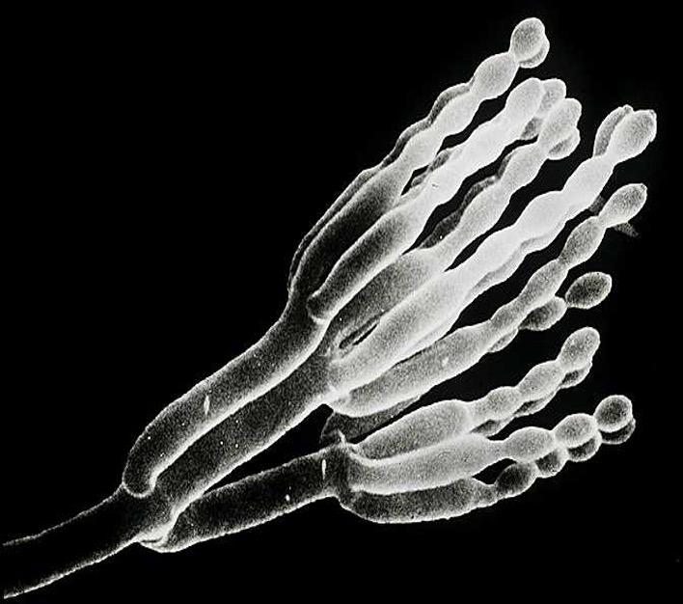
Fig. 6.2. Conidiophore producing asexual spores. From Tom Volk

It is important to understand that some filamentous fungi can produce asexually in addition to sexual reproduction. Understanding how particular fungi grow and reproduce can help us better develop sustainable treatments to protect crops and animals against certain pathogens.

Vegetative Compatibility
The concept of vegetative compatibility in fungi provides an additional layer of complexity to their reproductive and growth strategies. It goes beyond the simple mating type compatibility and involves a self/self-recognition system that governs hyphal fusion (anastomosis) and plasmogamy.
Fungi that possess vegetative compatibility can form complex, interconnected mycelial networks by fusing hyphae from the same or genetically similar individuals when they come into contact. This self/self-recognition system allows the fungus to build a more efficient, reticulated (net-like) structure. These networks offer several benefits:
- Improved Resource Acquisition: The mycelial network can spread more widely, reaching new resources, and allowing the fungus to more effectively exploit its environment.
- Increased Cytoplasmic Flow: The fusion of hyphae creates pathways for better flow of cytoplasm and nutrients throughout the fungal body.

Genetic Diversity
While vegetative compatibility might sound like a mechanism for self-fusion, it also helps increase genetic diversity. Here’s how:
- When two genetically distinct individuals (from different vegetative compatibility groups) come in contact, their hyphae may fuse, even if they are from different genetic backgrounds.
- If they are not compatible (i.e., their genotypes are sufficiently different), the bridge of cells connecting the two hyphae is often destroyed by programmed cell death. However, if the individuals are compatible, the fusion allows cytoplasmic exchange between the mycelia, which can include genetic information, endosymbionts, or even viruses.
This type of system is called self/close-enough-to-self recognition, meaning that fungi recognize when they are genetically similar enough to merge and share resources, but not so genetically distinct that they risk incompatibility. When fusion is successful, the resulting mycelium can contain a variety of heterogeneous nuclei (multiple different nuclear genotypes), allowing for multinucleate states. This means that even within one fungal body, different parts of the mycelium might have different genetic compositions, a process that enhances the fungus's adaptability.

Implications for Adaptation
- Increased Adaptive Ability: The diversity of nuclei within a single mycelium gives the fungus a wider range of genetic traits to draw upon, making it more adaptable to changing environmental conditions. For example, if one part of the mycelium encounters an unfavorable environment, another part (with a different genetic makeup) might fare better.
- Sectoring: When growing in a controlled environment, like a petri dish, a phenomenon called sectoring can occur. This means that different sections of the mycelium might show variations in phenotype, based on the different nuclear genotypes present. This can be a strategy to increase survival chances under fluctuating conditions.
- Nitrogen and Phosphorus Storage: In multinucleate, coenocytic fungi (those with continuous cytoplasm and multiple nuclei), the presence of extra nuclei may serve as nutrient sinks, especially for nitrogen and phosphorus. These nutrients can be stored and then used as needed, which is helpful when resources are limited. This process may even occur through autophagy, where the fungus breaks down its own parts to recycle materials.

Vegetative compatibility allows fungi to form extensive mycelial networks by fusing hyphae from genetically similar or compatible individuals. This system not only promotes growth and resource acquisition but also enhances genetic diversity and adaptive potential. The ability to have multiple genetic backgrounds within a single mycelium increases a fungus’s fitness by providing flexibility in different environments, and it can even help store essential nutrients like nitrogen and phosphorus for future use. Essentially, this mechanism allows fungi to self-organize and adapt in ways that give them a greater edge in surviving and thriving in diverse or changing environments.
Yeasts:
Yeasts are fascinating single-cell fungi, primarily belonging to the Ascomycota group, although some Basidiomycota species, like Cryptococcus neoformans (a human pathogen), also exhibit a yeast-like growth form. Other fungi can grow both fiamentous and yeast morphologies, depending on the environment (referred to as ‘dimorphic’). Yeasts are incredibly versatile organisms, both in their biological characteristics and their wide-ranging applications.

Reproduction of Yeasts
Yeasts can reproduce asexually and sexually:
- Asexual Reproduction (Budding):
  - The most common form of asexual reproduction in yeasts is budding. In this process, a parent cell produces a smaller, genetically identical daughter cell by pinching off part of its body. This method can continue indefinitely, given the right conditions (e.g., nutrient availability, temperature).
  - Budding often results in asymmetric division, with the daughter cell typically being smaller than the parent cell at first. Over time, asymmetrical budding or stressful environments can cause the yeast cells to age and senesce (enter a state where they stop reproducing), producing a finite number of daughter cells.
- Sexual Reproduction:
  - Yeasts can also reproduce sexually, which involves genetic recombination. In this process, two compatible haploid cells (spores) fuse, resulting in the formation of a diploid zygote. This allows for genetic variation, which can be beneficial for adaptation to changing environments.
  - The sexual life cycle in yeasts can include the formation of structures like ascus (in Ascomycota), where spores are formed after meiosis.

Applications of Yeasts
One of the most intriguing applications of yeasts is in bioengineering. For example, yeasts have been used to produce cannabinoids like CBD and THC. Scientists can insert genes responsible for CBD/THC synthesis into Yarrowia lipolytica (a yeast species), allowing the yeast to produce cannabinoids when cultured in a sterile medium. The cannabinoids are then exuded into the liquid, which can be harvested and purified. This approach is significantly faster than growing cannabis plants, making it a promising avenue for efficient cannabinoid production.

Yeast in Cannabis Production
- The genetic engineering of yeasts to produce cannabinoids is one of the innovative ways in which biotechnology is being used to improve the production of valuable compounds. This process reduces the time and resources required to produce cannabinoids compared to traditional agricultural methods.
- Yeasts, with their ability to multiply rapidly and in controlled conditions, offer a scalable and sustainable method for cannabinoid production, especially in research or industrial contexts.

The “Lower” Fungi
The term "Lower Fungi" refers to fungal groups that lack the dikaryon formation seen in the Dikarya (Basidiomycota and Ascomycota). The "lower" designation does not imply that these fungi are less important or evolutionary "primitive," but rather that they lack certain features like the dikaryotic life stage. All organisms, including these fungi, have evolved for the same duration from a common ancestor, and the term "lower" is historical rather than evolutionary in value. A more accurate term might be "more- or less-derived" from an ancestral state.

Glomeromycotina and Mucormycotina
- Glomeromycotina (Arbuscular Mycorrhizal Fungi):
  - These fungi are crucial for forming arbuscular mycorrhizae, a symbiotic relationship with plant roots, primarily aiding in nutrient uptake.
  - While sexual reproduction has been debated, asexual reproduction is more commonly observed. This involves the production of spores that are used for fungal dispersal.
  - Chlamydospores, thick-walled, asexual spores, allow these fungi to survive in harsh conditions. These spores may contain multiple nuclei and require plant root signals for germination.
- Mucormycotina:
  - Mucormycotina fungi are typically dispersed by asexual spores but can also reproduce sexually via the formation of zygospores. This sexual process involves the attraction of compatible mating types using volatile chemicals, leading to the formation of a zygosporangium.
  - These fungi are considered important mycorrhizal fungi and have recently gained attention for their ecological roles.

Chytridiomycota
- Chytrids represent one of the most ancestral fungal life cycles. They produce zoospores, which are motile spores with flagella that can swim in aqueous environments. These zoospores can be haploid or diploid depending on the species.
- Male and female gametes are produced in some species, with both being mobile, while in others only the male gametes are motile.
- Interestingly, some Chytrid species can be cultured using sterile hemp seeds as bait.

Oomycota (Water Molds)
- Oomycota (often called water molds) are not true fungi but are eukaryotes classified as heterokonts. They are more closely related to diatoms and brown algae than to true fungi.
- Asexual reproduction in Oomycota involves the production of zoospores (flagellated spores) or sporangiospores, which can swim to infect new host plants. They can also form cysts for long-term survival.
- Sexual reproduction in Oomycetes involves the formation of oogonia (female) and antheridia (male), which fuse to form diploid oospores. These oospores can infect new plants and begin the cycle again.

Fungi Imperfecti (Deuteromycota)
- Deuteromycota (or Fungi Imperfecti) are fungi that only reproduce asexually, often through the formation of conidia or spores. These fungi do not have a known sexual stage and are considered “imperfect” because they lack observed sexual reproduction.
- Though they lack sexual reproduction, genetic novelty can still arise through mechanisms such as vegetative compatibility or the parasexual cycle.

Actinobacteria (formerly Actinomycota)
- Actinobacteria are a group of gram-positive bacteria that resemble filamentous fungi. They are prokaryotic organisms and reproduce by forming arthrospores or conidia rather than through sexual reproduction.
Conclusion
Fungal reproduction is varied, with many successful strategies having developed that can seem quite different from sex among animals with which many readers are more familiar. Now that we have a better understanding of how fungi grow and reproduce we will look at some specific examples of how particular fungi interact with the Cannabis plant.

In summary:
- All fungi reproduce via spores
- Most fungi must fuse with a compatible mating type before producing a fruiting body
- Some fungi can produce both sexual and asexual spores

